Nepal College of Information Technology
Balkumari, Lalitpur
Assessment-Fall 2009

Program: BE Time: 3 hrs
Semester: Fall FM: 100
Subject: Physics PM: 50
Attempt ALL the questions. Figures at the margin indicate their full marks.

1. a) What are the limitations of a simple pendulum? Deduce the formula for the time period of a compound pendulum and show that it is minimum when the length of the pendulum is equal to the radius of gyration. 2+5+2
b) The maximum pressure variation that the car can tolerate in loudspeaker is about 28 N/m². Normal atomspheric pressure is 10⁵ N/m². Find the corresponding maximum displacement for a sound wave in air having frequency of 1000 cycles/sec. Given: density of air = 1.293 kg/m³ and velocity of sound in air is 343 m/s. 6
OR
A wave pulse is traveling on a string of linear mass density 2 g/cm and hanging mass of 2 kg. Find the time taken by pulse in traveling through a distance of 100 cm on the string ( g = 10 m/s²). 6
2. a) Define wave motion. Show that in terms of tension T and linear mass density μ, the speed v of a wave on a stretched string is given by 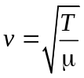 2+7
OR
Explain the effects of relative motion of source or the observer to the frequency of sound wave. Find the expression for apparent frequency when the source and observer are moving. 4+5
b) A motor car is approaching a road crossing with speed of 75 km/hr. A constable standing near the crossing hears the frequency of its horns 260 Hz. What is the real frequency of horn? The speed of sound in air = 332 m/s. 6

3. a) What is power of lens? Two convex lenses of focal lengths f₁ and f₂ are coaxially separated by d. Derive the formula for the equivalent focal length and the power of the combined lens system. 2+7
OR
Explain chromatic aberration with figure. Show that 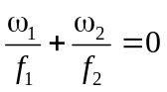 where the symbol have their usual meanings. 3+6
b) Two thin converging lenses of focal lengths 30 cm and 40 cm are placed coaxially 20 cm apart. An object placed at a distance of 48 cm from the first lens. Find i) the position of the image ii) the position of the principal points and iii) the position of the focal points. Indicate these positions in a diagram. 6

4. a) What is interference? Find the condition of constructive and destructive interference in thin film by reflected light. 2+7
b) A screen is placed 2 m away from a narrow slit which is illuminated with white light of wavelength 6000Ǻ, if the first minimum lies 5 mm on the either side of the central maximum, calculate the slit width. 6
OR
Determine the specific rotation using the following data: length of tube = 20 cm, volume of tube = 120 cm³, quantity of sugar dissolved = 6 g, angle of rotation of analyzer for restoring equal intensity = 6.6º.
5. a) Define electric potential. What is dipole? Obtain the potential at a point due to a dipole. 2 +1 + 6
b) In the given figure below, find the equivalent capacitance between x and y, assume that C₂ = 10 μF and that the other capacitors are all 4 μF. 6
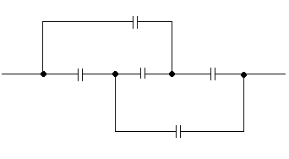
C₁
C₃
C₂
C₅
C₄
x
Y

6. a) What do you mean by polar and non-polar dielectrics? Discuss the behavior of dielectric in a parallel plate capacitor and on the basis of Gauss's law of electrostatics; show that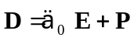, each symbol has its usual meaning. 9
b) What is the equivalent resistance of the network shown? What are the currents in each resistor?
Given R₁= 100Ω, R₂ = R₃ = 50 Ω, R₄ = 75 Ω and E = 6V. 6

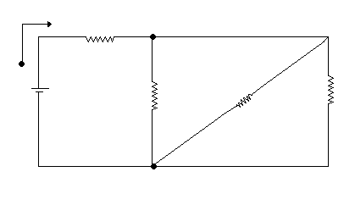
R₁
E
R₂
R₃
R₄
7. Write short notes on (any two) (5x 2=10)
i) Brewster's law
ii) Coma
iii) Kirchoff's current law

